Oral Surgery Form

Date: ____________________

Referred By: _____________________________

Patient Name:_____________________________________

Patient Dob:_____________________________ (MM/DD/YY)

Patient Ph#:_____________________________

( ) Extractions
( ) Expose and Bond
( ) Pathology
( ) Implants
( ) Tori / ( ) Alveoloplasty

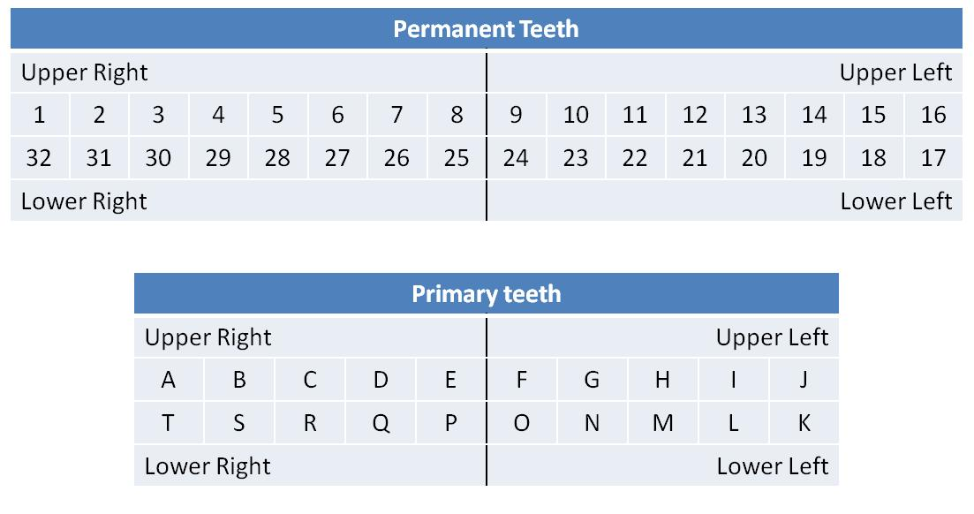
Notes:_____________________________________________________________________________
__________________________________________________________________________________
__________________________________________________________________________________

